1. Download mariadb by running the installation.exe in provided in the instructions folder or download the installer from the mariadb main website

Default username: root

Default password: root

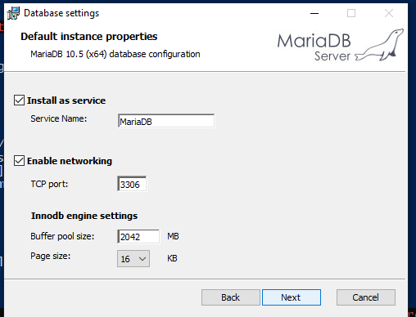

1. Launch a terminal window
2. Change the directory to the corresponding data folder of the exercise desired

Example:

cd C:\Users\Username\Desktop\Web-Security-master\01-Injection\01-Vulnerable-App\Bank-App\data

1. Run in the terminal:

C:\Windows\System32\cmd.exe /k "set MYSQL_HOME=C:\Program Files\MariaDB 10.5\data\&& set PATH=C:\Program Files\MariaDB 10.5\bin\;%PATH%;&&echo Setting environment for MariaDB 10.5 (x64) "

1. Run in the terminal:

mysql -u root -p -h localhost

1. Input username and password in: defaults are root and root
2. Run in the terminal command

source createdb.sql

1. Run in the terminal command

source populatedb.sql

Steps 2 – 8 must be performed each time the user changes to another exercise until the containerization is implemented.